**CS 200: Computer Organization**

**Project 2: Counter with Display**

Shariq M. Jamil

Due: Friday, February 14, 2014

**Overview**

**Purpose**

This project required us to design a BCD counter that will control a 7-segment display.

**Approach**

This project was a complete exercise in designing a circuit from scratch. We were provided an idea of how a modulo-10 counter could be used to operate a 7-segment display and, we used it to define input (4-bit input) and output variables (seven, one for each segment on a 7-segment display). A truth table was created using the variables and a Boolean function for each output was produced using it. A circuit was then assembled to show how a binary-coded decimal counter can control a 7-segment display. The circuit I built first was messy, so I entered ensured the truth table in Logisim was accurate and then used the “Build Circuit” function. Another circuit was created to show how a modulo-10 counter built with JK flip flops can operate a 7-segment display.

**Solution**

A truth table showing all combinations of inputs and outputs.

|  |  |  |  |  |  |  |  |  |  |  |  |
| --- | --- | --- | --- | --- | --- | --- | --- | --- | --- | --- | --- |
| **X3** | **X2** | **X1** | **X0** | **A** | **B** | **C** | **D** | **E** | **F** | **G** | **Number**  **Displayed** |
| 0 | 0 | 0 | 0 | 1 | 1 | 1 | 1 | 1 | 1 | 0 | 0 |
| 0 | 0 | 0 | 1 | 0 | 1 | 1 | 0 | 0 | 0 | 0 | 1 |
| 0 | 0 | 1 | 0 | 1 | 1 | 0 | 1 | 1 | 0 | 1 | 2 |
| 0 | 0 | 1 | 1 | 1 | 1 | 1 | 1 | 0 | 0 | 1 | 3 |
| 0 | 1 | 0 | 0 | 0 | 1 | 1 | 0 | 0 | 1 | 1 | 4 |
| 0 | 1 | 0 | 1 | 1 | 0 | 1 | 1 | 0 | 1 | 1 | 5 |
| 0 | 1 | 1 | 0 | 0 | 0 | 1 | 1 | 1 | 1 | 1 | 6 |
| 0 | 1 | 1 | 1 | 1 | 1 | 1 | 0 | 0 | 0 | 0 | 7 |
| 1 | 0 | 0 | 0 | 1 | 1 | 1 | 1 | 1 | 1 | 1 | 8 |
| 1 | 0 | 0 | 1 | 1 | 1 | 1 | 0 | 0 | 1 | 1 | 9 |

Non-minimized Boolean functions for each segment.

SegTop (A) = (E1 + E4 + E6)’

SegTopRight (B) = (E5 + E6)’

SegBottomRight (C) = (E2)’

SegBottom (D) = (E1 + E4 + E7 + E9)’

SegBottomLeft (E) = (E1 + E3 + E4 + E5 + E7 + E9)’

SegTopLeft (F) = (E1 + E2 + E3 + E7)’

SegCenter (G) = (E0 + E1 + E7)’

**Sample Output**

The circuit below shows 4 inputs of a binary decimal counter (BCD) controlling 7 outputs (one for each segment in a 7-segment display.

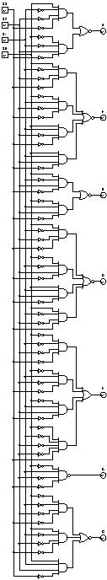

The circuit was then used as a sub-circuit to show a modulo-10 counter built using JK flip flops operating a 7-segment display. The “Enable” switch is turned on first and then “Count” is clicked repeatedly to see the 7-segment display show numbers in proper succession.

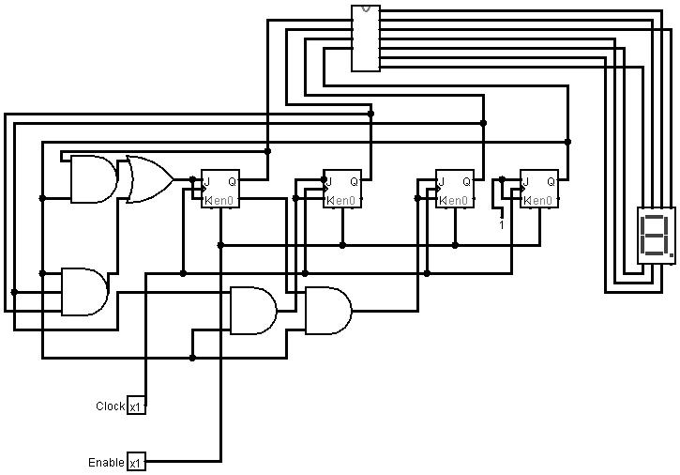

**Conclusion**

This was a great exercise for building on for everything we have covered in class because it required an intense use of truth tables and Logisim. This circuit required a lot more outputs than the previous lab and had numerous functions for each of the segments which was good source of practice in circuit design. It also took me time to figure out how to build the modulo-10 counter with JK flip flops but reading the relevant chapters in the book and drawing it out on a whiteboard helped a lot. Overall, this was an excellent module on more advanced Logisim circuit design now that we know the basics of the software and being able to see the outputs on the 7-segment display was very fulfilling.